Machine Learning Short Notes – Andrew Ng Week 1

- Machine learning: "Field of study that gives computers the ability to learn without being explicitly programmed"
- Well posed learning problem: "A computer program is said to learn from experience E with respect to some class of tasks T and performance measure P, if its performance at tasks in T, as measured by P, improves with experience E."
- Example: The checkers example,
- E = 10000s games
- T is playing checkers
- P if you win or not
- Several types of learning algorithms under Machine Learning
- Supervised learning
  - Teach the computer how to do something, then let it use it’s new found knowledge to do it by specifying what you want.
  - Can be classified as:
- Regression Problems: are the ones in which the algorithm is expected to produce a continuous value output/graph , based on a historical input of data provided.
- Classification Problems: In classification problems, can have a discrete number of possible values for the output. Just like binary 1s or 0s. There’s no in-between. The discrete number of values can be many – say 2,3,4...n etc.

- Unsupervised learning
  - Let the computer learn how to do something, and use this to determine structure and patterns in data without specifying what is required from the computer.
  - Can be classified as:
- Clustering Problems: are the challenges in which the algorithm will divide or segment the given data into clusters based on the similarities and differences in their features.
- Non-Clustering Problems: are the ones in which similar data is separated like clustering but no clustering is seen but data is separated completely from each other and separated as different datasets.
- A hypothesis function takes in some variable
- Uses parameters determined by a learning system or an input dataset.
- Outputs a prediction based on that input.
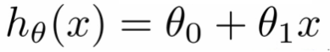
- Hypothesis Function:

- Hypothesis- is like your prediction machine, throw in an x value, get a corresponding y value. If you observe the equation it looks like a straight line equation which is also what the graph looks like.
- A cost function lets us figure out how to fit the best straight line to our data. Cost is a way to use your training data, determine values for your θ values which make the hypothesis as accurate as possible.
  - Cost Function Equation(Implementation of linear regression problem):
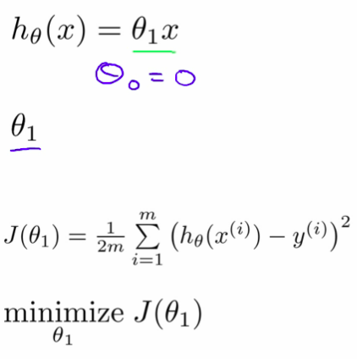

- This cost function is also called the squared error cost function, As we can see the error being squared in the above equation.
- Gradient Descent has one global optima/ optimal minima and will always converge to that optima and is hence used to minimize the squared error cost function and obtain an optimal value.
  - Equation of Gradient Descent for a cost function J:
